**TRINITY INTERNATIONAL COLLAGE**

**DILLIBAZAR, KATHMANDHU**

**TU AFFILIATED**

**BACHELOR OF COMPUTER APPLICATION**



**Lab REPORT ON MATHEMATICS**

**AND MATHLAB**

**SUBMITTED BY: SUBMITTED TO:**

**Pradeep Bikram Thapa Department of BCA**

**Abstract**

**It’s our pleasure and duty to submit report of mathematic and math lab. It is the syllabus of BCA first semester program affliliated to Tribhuvan University. The main goal of this lab report is to make students understand about practical knowledge and concept of mathematic and math lab about how to solve mathematical problem in lab. This is the main point of view of this report.**

**Acknowledgment**

**I would like to express my special thanks of gratitude to our teacher”Mr.Chandramani Bhattarai” as well as our campus chief “Umesh Thapa” who gave us opportunity to make report of mathematic and math lab which helped me in doing a lot of research and I came to know about many things so I am very thankful to them. I would like to thank friends and teacher who helped me in making this project with a limited frame a time.**

**Content**

1. **Software Application in Mathematic and math lab**

* **Introduction**
* **Mathematic**
* **Math lab**

1. **Features of mathematic/math lab**
2. **Uses of mathematic and math lab**
3. **Relation, Function and Graph**

**Lab-1**

1. **Matrices and Determinants**

* **Lab-2**

1. **Vector**

* **Lab-3**

**Software application on Mathematic and math lab**

**Introduction: There are many software applications which are available for mathematics, they are;**

**1. Mathematic**

**2. Math lab**

**3. Moped**

**4. Magma**

**5. GAP etc.**

**But mainly we will study about two software: they are:**

**Mathematic: Mathematic is a symbolic mathematic computation program some time called a computer Algebra program. It is commercial software started in 1998. It was conceived by Stephen Wolfram developed by Wolfram research of campaign. The Wolfram language is a programming language in Mathematic. It is used for general purpose in computer Algebra systems(CAS) and also use in main scientific engineering and Economic fields.**

**Features of Mathematic:**

1. **It provide an interactive environment for interactive exploration design and problem solving.**
2. **It provides tools for buildings application with custom graphic interface.**
3. **It provides vast library of Mathematic location for linear algebra etc.**
4. **It provides function integration Mathematic based algorithms with external application and world from language such as c++, Java.**

**Uses of Mathematic:**

1. **To draw parabola, ellipse, circle etc.**
2. **We easy to find determinant of matrix like and cross matrix.**
3. **It also help in the problem like geometrical problems.**
4. **It also helps in findings scientific value.**

**Math lab:**

**Math lab is a computer algebra system created in 1964 by Carl Engelmann at MITRE and written in Lisp. Math lab 68 was introduced in 1967 and became rather popular in university environments running on DECs PDP-6 and under TOPS-10 or TENEX. In 1969 versions was included in the DECUS user groups library (as 10-142) as royalty-free software.**

**Features of Math lab:**

**MATHLAB is an on-line system providing machine aid for the mechanical symbolic processes encountered in analysis. It is capable of performing, automatically and symbolically, such common procedures as simplification, substitution, differentiation, polynomial factorization, indefinite integration, direct and inverse Laplace transforms, the solution of linear differential equations with constant coefficients, the solution of simultaneous linear equations, and the inversion of matrices. It also supplies fairly elaborate bookkeeping facilities appropriate to its on-line operation.**

**Uses of Math lab:**

**Math lab 68 has been used to solve electrical linear circuits using an acausal modeling approach for symbolic circuit analysis. This application was developed as a plug-in for MATHLAB 68 (open-source), building on MATHLAB linear algebra facilities (Laplace transforms, inverse Laplace transforms and linear algebra manipulation).**

**Lab ASSIGNMENT -1**

**By using Mathematic.**

1. **Factorize the following.**
2. **x5-y5**

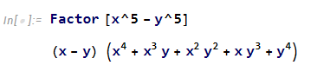

1. **16x4+4x2y2+y4**

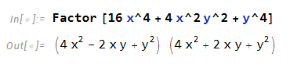

1. **Expand the following.**

**a.(2x-2y)2**

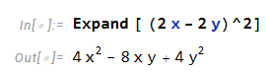

**b.(a+5b)3**

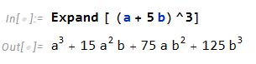

1. **Solve the following**.
2. **X2+3x+1=0**

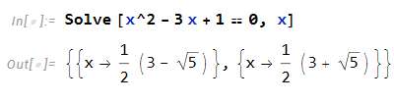

1. **2x2+8x-11=0**

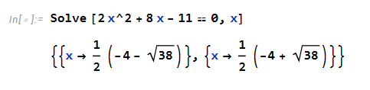

1. **Plot the graph of the following in the graph.**
2. **F(x)=2x+7, where x:5<x<15}**

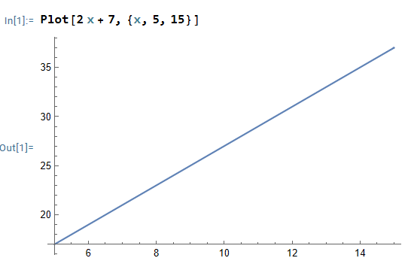

1. **G(x)=5x2 + 2x +5 where {x:-10< X < 10}**

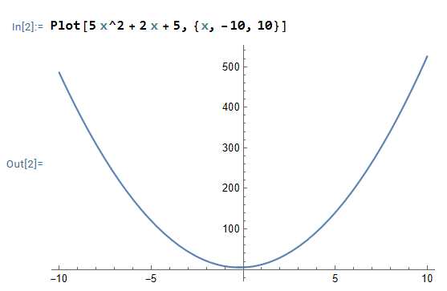

1. **H(x)=sinx, where {x: -x < x < x}**

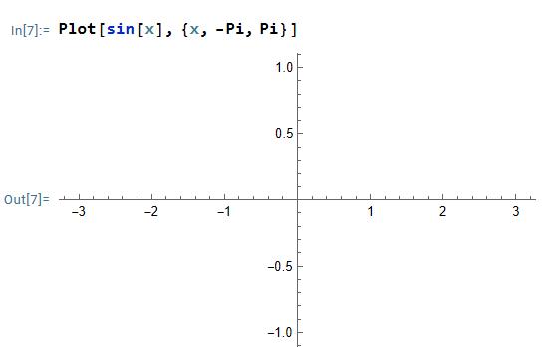

1. **R(x)=ex, where {x: -5 < x < 5}**

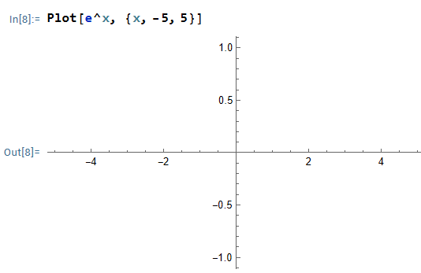

1. **S(x)=x3, where {x: -10 < x < 10}**

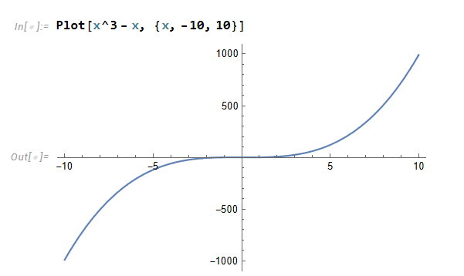

**LAB ASSIGNMENT 2 (Matrices and Determinant )**

**By using Math lab**

1. **Find the size of the following matrices.**

$\begin{matrix}1 & 3 & 6 \\ 0 & 2 & 7\end{matrix}$

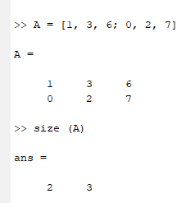

$\begin{matrix}1 & 2 & 3 \\ 0 & 2 & 5 \\ -2 & 4 & 0\end{matrix}$

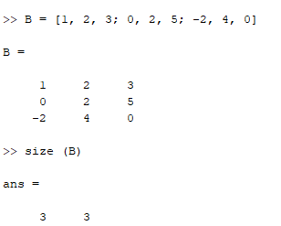

$\left[\begin{matrix}1 & 0 & -2 \\ 2 & 1 & 3 \\ 3 & 4 & -1 \\ 4 & 5 & 3 \\ 6 & 0 & -3\end{matrix}\right]$

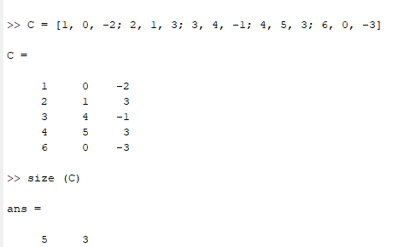

1. **(i)If A= $\left(\begin{matrix}1 & 3 & 6 \\ 0 & 2 & 7\end{matrix}\right)$ and B= $\left(\begin{matrix}8 & 34 & -5 \\ 0 & 6 & -5\end{matrix}\right)$. Find A + B**

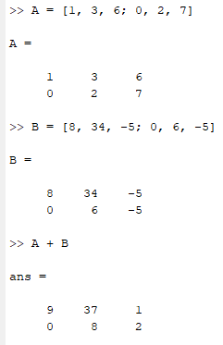

**(ii) If A = $\left[\begin{matrix}-5 & 2 & 6 \\ -8 & 6 & 9 \\ -2 & 4 & 0\end{matrix}\right]$ and B= $\left[\begin{matrix}10 & 5 & 7 \\ -9 & -4 & 9 \\ 12 & -2 & 1\end{matrix}\right]$. Find A – B**

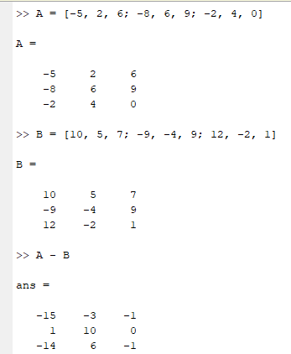

1. **Find the determinants of the following matrices.**

**(i) $\left[\begin{matrix}-5 & 2 & 5 \\ -8 & 6 & 9 \\ -2 & 4 & 0\end{matrix}\right]$**

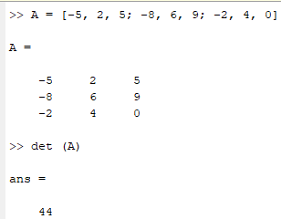

**(ii) $\left[\begin{matrix}10 & 5 & 7 \\ -9 & 4 & 9 \\ 12 & -2 & 1\end{matrix}\right]$**

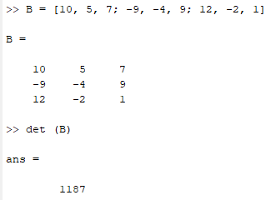

**(iii). $\left[\begin{matrix}0 & 1 & 6 & 8 & 1 \\ 0 & 2 & 5 & 7 & 8 \\ -2 & 8 & 3 & -2 & 1 \\ 1 & 3 & 6 & 6 & 2 \\ 3 & 9 & 0 & 8 & 0\end{matrix}\right]$**

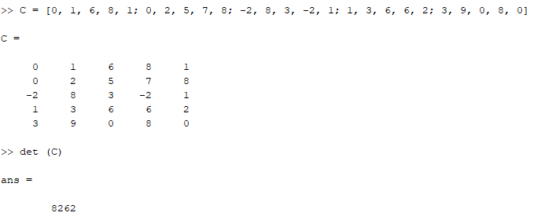**4. Find the rank of the following matrices.**

**(i) $\left[\begin{matrix}1 & 3 & 6 \\ 0 & 2 & 7\end{matrix}\right]$**

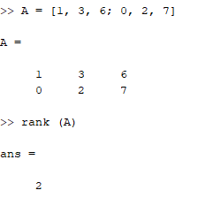

**(ii) $\left[\begin{matrix}1 & 0 & -2 \\ 2 & 1 & 3 \\ 3 & 4 & -1 \\ 4 & 5 & 3 \\ 6 & 0 & -3\end{matrix}\right]$**

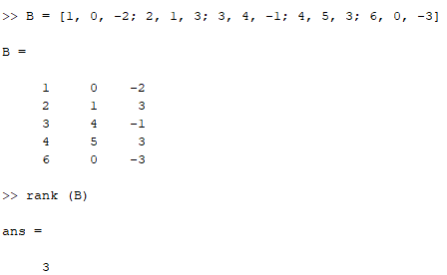

**(iii) $\left[\begin{matrix}10 & 5 & 7 \\ -9 & -4 & 9 \\ 12 & -2 & 1\end{matrix}\right]$**

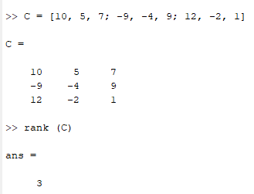

**5.(i)If A = $\left(\begin{matrix}1 & 3 & 6 \\ 0 & 2 & 7\end{matrix}\right)$ and B= $\left(\begin{matrix}10 & 5 & 7 \\ -9 & -4 & 9 \\ 12 & -2 & 1\end{matrix}\right)$. Find AB**

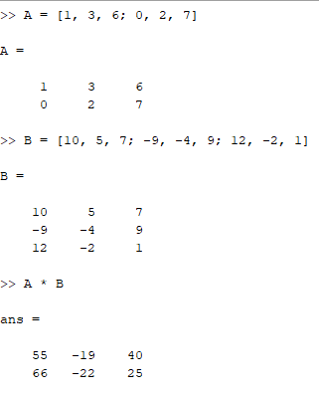

**(ii)If A= $\left(\begin{matrix}1 & 3 & 6 \\ 0 & 2 & 7\end{matrix}\right)$ and B= $\left(\begin{matrix}1 & 1 \\ 2 & 0 \\ 3 & 5\end{matrix}\right)$. Find AB and BA**

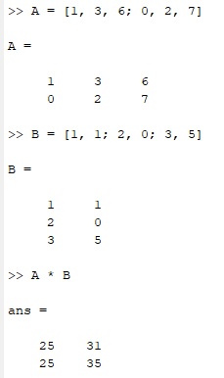

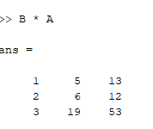

**(6) Find inverse of the following matrices if possible.**

**(i) $\left[\begin{matrix}10 & 5 & 7 \\ -9 & -4 & 9 \\ 12 & -2 & 1\end{matrix}\right]$**

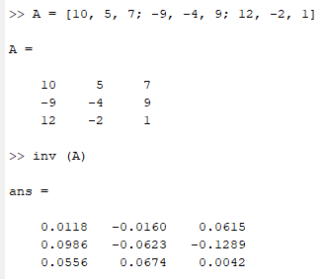

**(ii) $\left[\begin{matrix}0 & 1 & 6 & 8 & 1 \\ 0 & 2 & 5 & 7 & 8 \\ -2 & 8 & 3 & -2 & 1 \\ 1 & 3 & 6 & 6 & 2 \\ 3 & 9 & 0 & 8 & 0\end{matrix}\right]$**

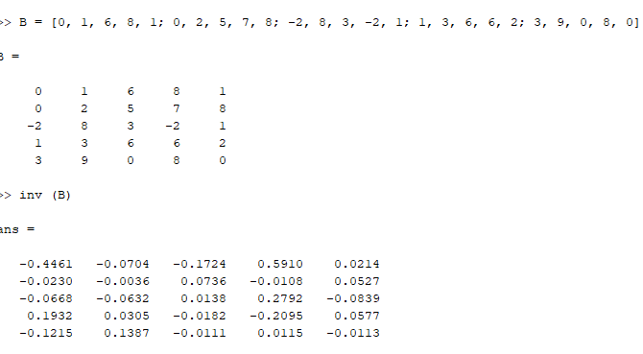

**7.**F**ind the adjoint of the matrix $\left[\begin{matrix}-5 & 2 & 6 \\ -8 & 6 & 9 \\ -2 & 4 & 0\end{matrix}\right]$** **.**

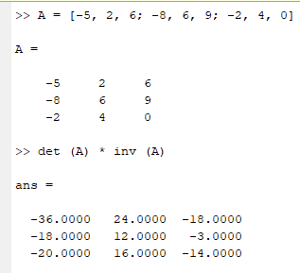

(**8) Solve the following linear equation.**

**(i) 2x+3y+z=2.**

**(ii) 3x-2y-z=6.**

**(iii) 5x+7y-3z=10.**

**(9) If A = $\left[\begin{matrix}1 & 2 \\ 3 & 1\end{matrix}\right]$, Find the value of : A2 – 2A – 5I**

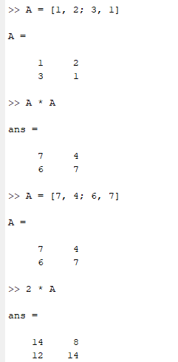

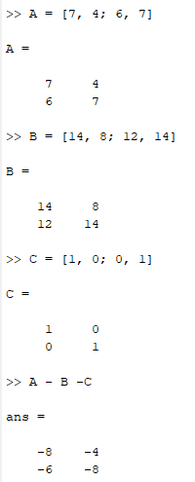

**(10) If A $\left[\begin{matrix}1 & 0 & 0 \\ 4 & 2 & 3 \\ 2 & 0 & 1\end{matrix}\right]$, find A2 – A – I.**

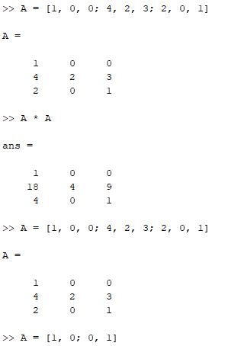

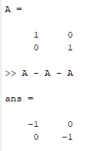

**LAB ASSIGNMENT -3**

**BY USING MATH LAB**

1. **Plot the graph of the following function.**
2. **Y = sin x in [- $π,$ $π]$**

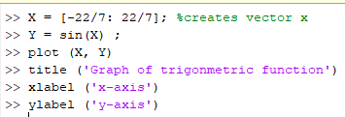

**Output:**

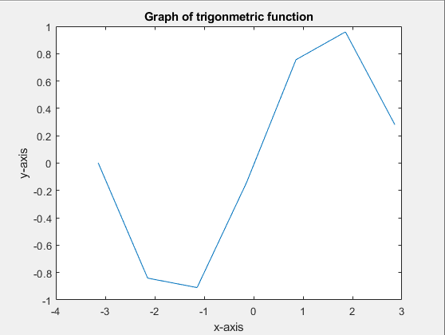

1. **Y= x3 – 3x + 4 in [ -10, 10]**

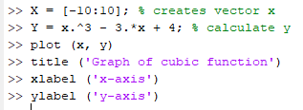

**Output:**

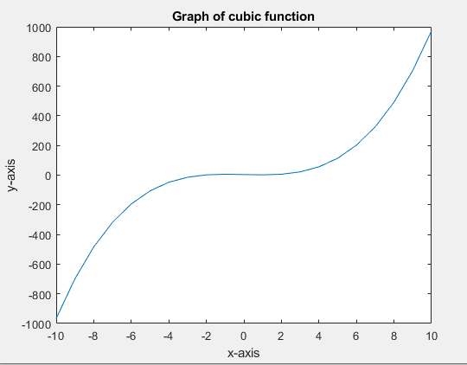

1. **Y= log x in(0, 100)**

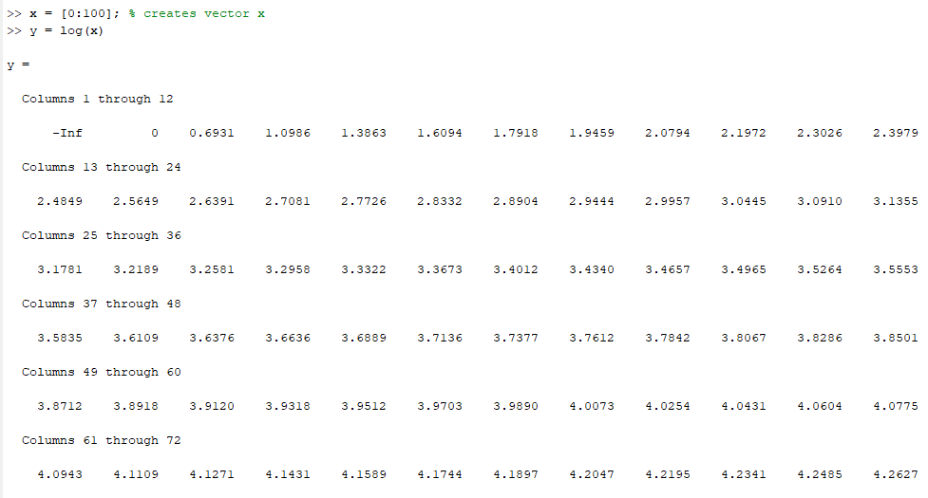

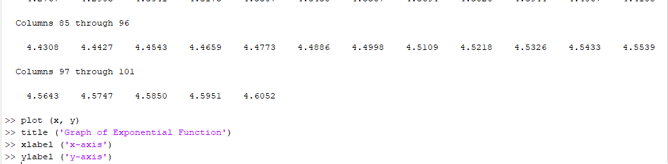

**Output:**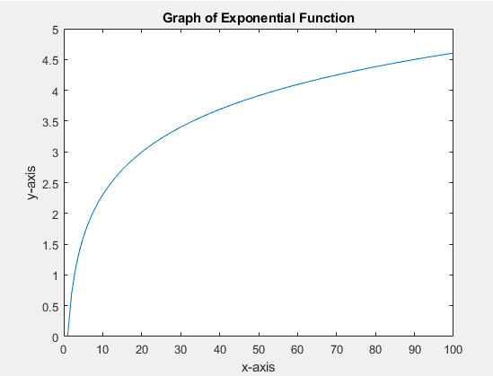

1. **If $\vec{u}$ = 2 $\vec{i}$ + 8 $\vec{j}$– $\vec{k}$, $\vec{v}$ = - $\vec{i}$ + 9 $\vec{j}$– 7 $\vec{k}$ and $\vec{w }$ = 4 $\vec{i }$– 11 $\vec{j}$ + $\vec{ k}$ then find,**
2. **+**

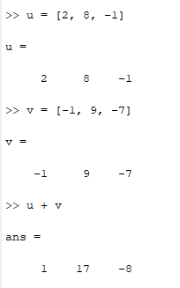

1. **-**

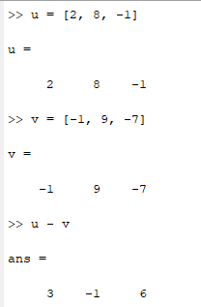

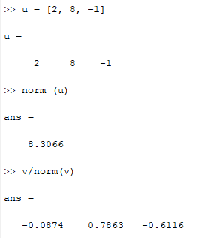

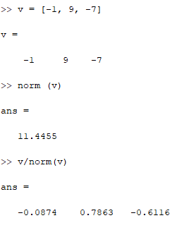

1. **| + |**

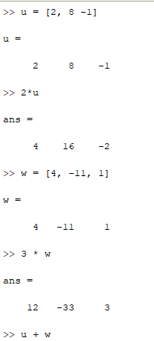

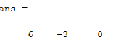

1. **If $\vec{a }$ = -2 $\vec{i}$– 7 $\vec{j}$ + 2 $\vec{k }$, b = $\vec{I}$– 7 $\vec{j}$ + 10 $\vec{k}$ and $\vec{ c}$ = $\vec{ I}$ + 10 $\vec{j}$ + 3 $\vec{k}$ then find,**

$\vec{a}$ $\vec{b}$
2. **\***

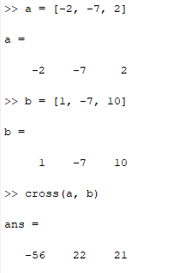

1. $\vec{a}$**. $\vec{b}$**

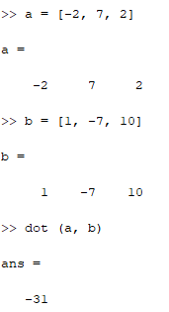

1. $\vec{a}$**.($\vec{b}$ $\vec{c}$*)**

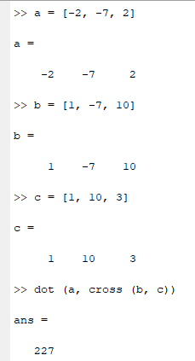

1. $\vec{a}$**\*($\vec{b}$ $\vec{c}$*)**

